**Week – 2 :**

Projection View:

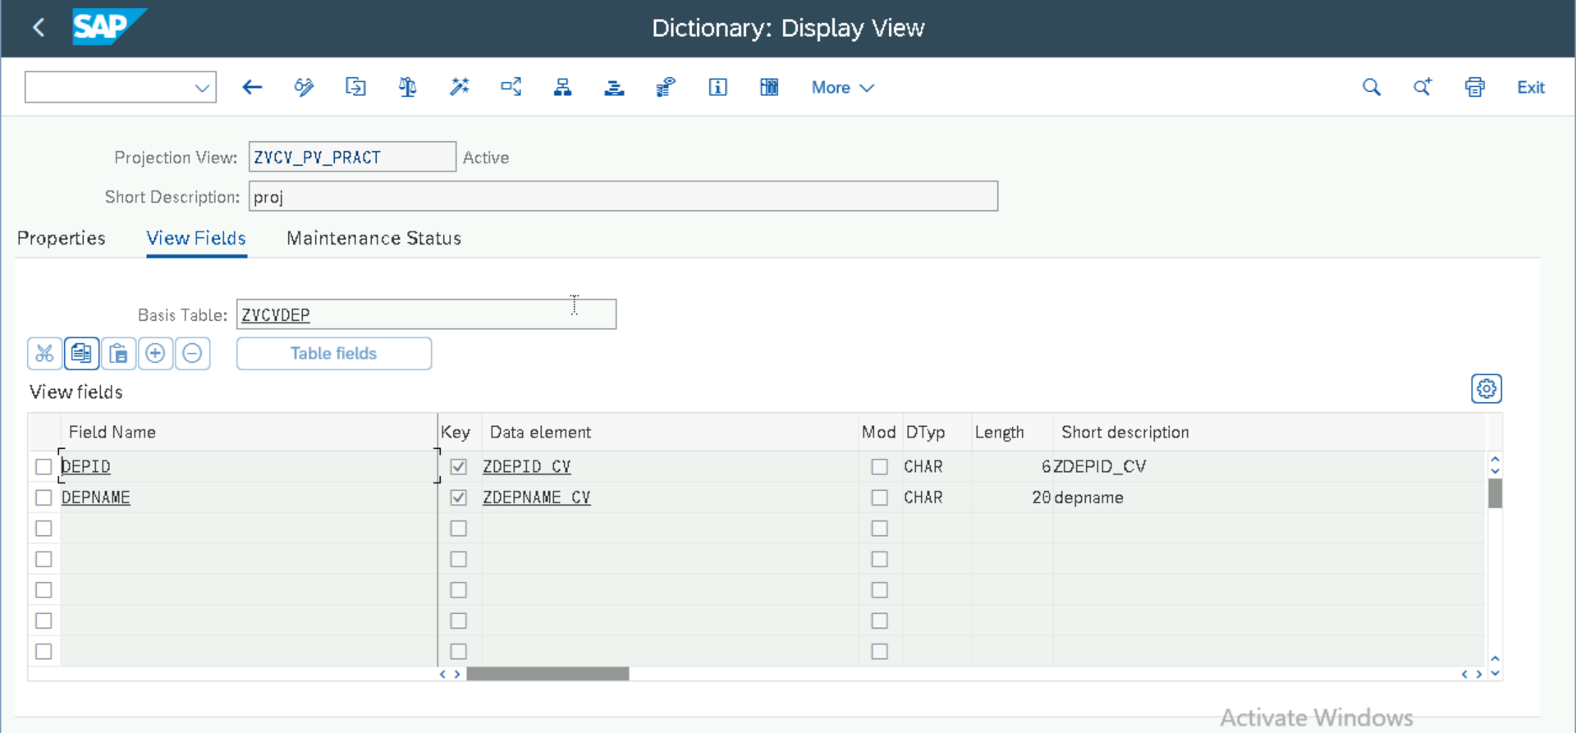

Output:

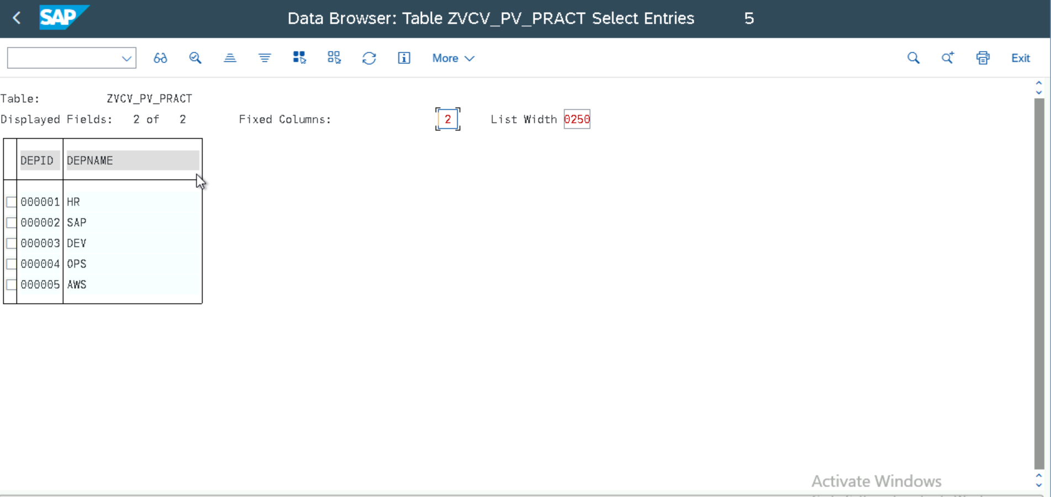

Maintenance View:

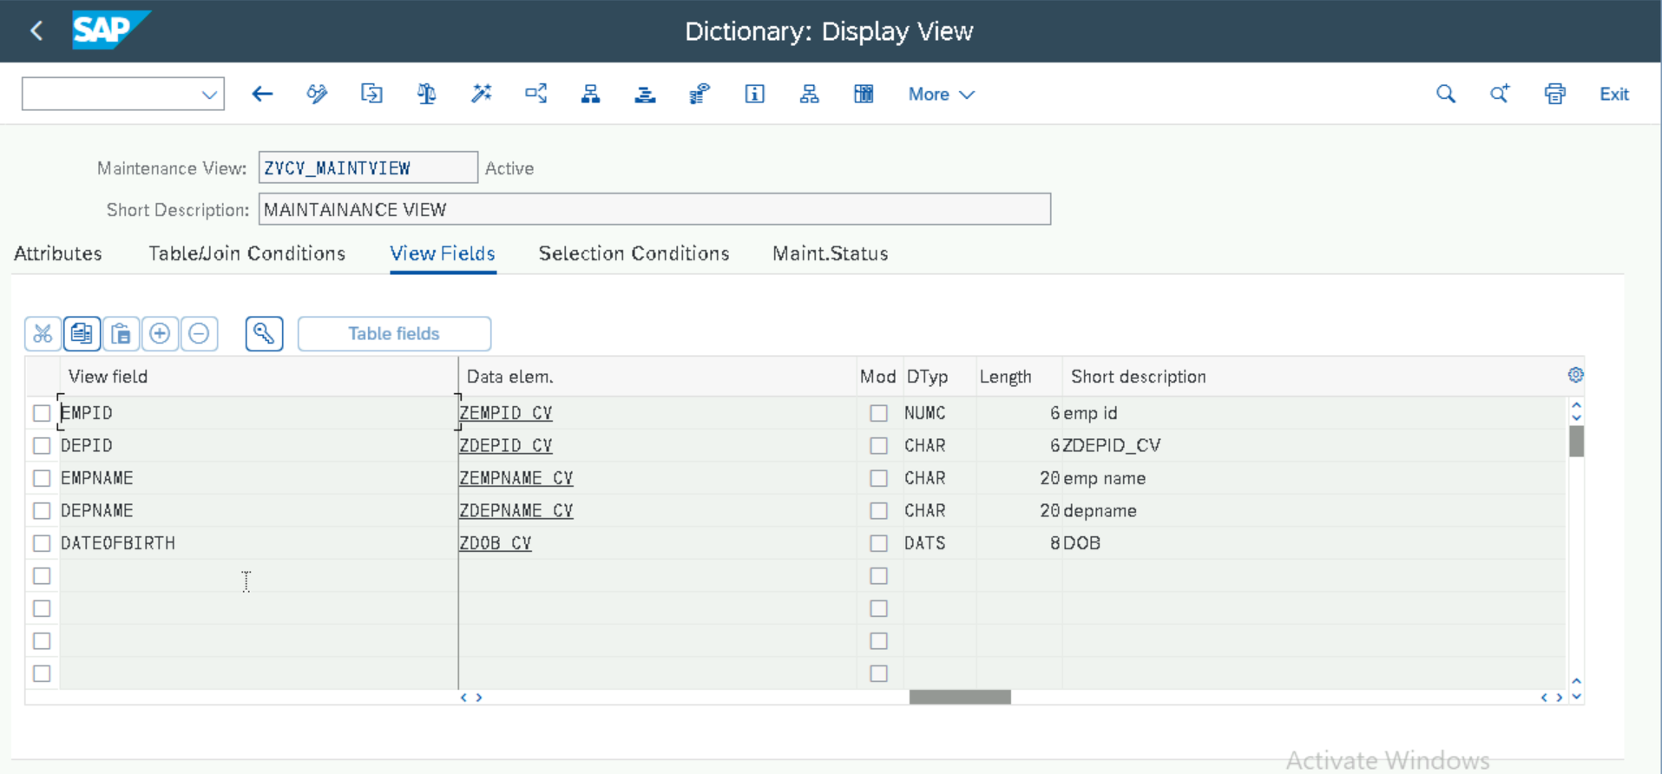

Output:

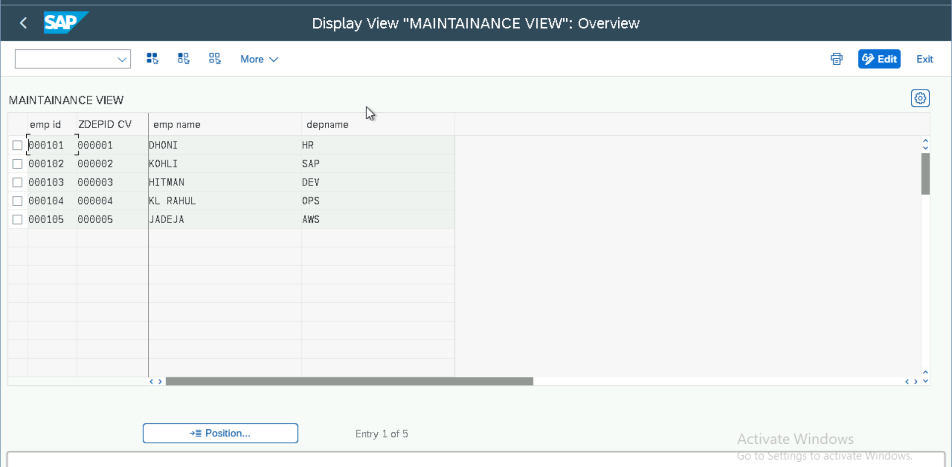

Lock Object:

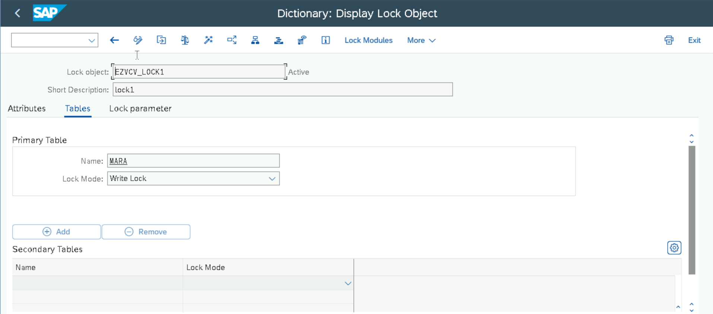

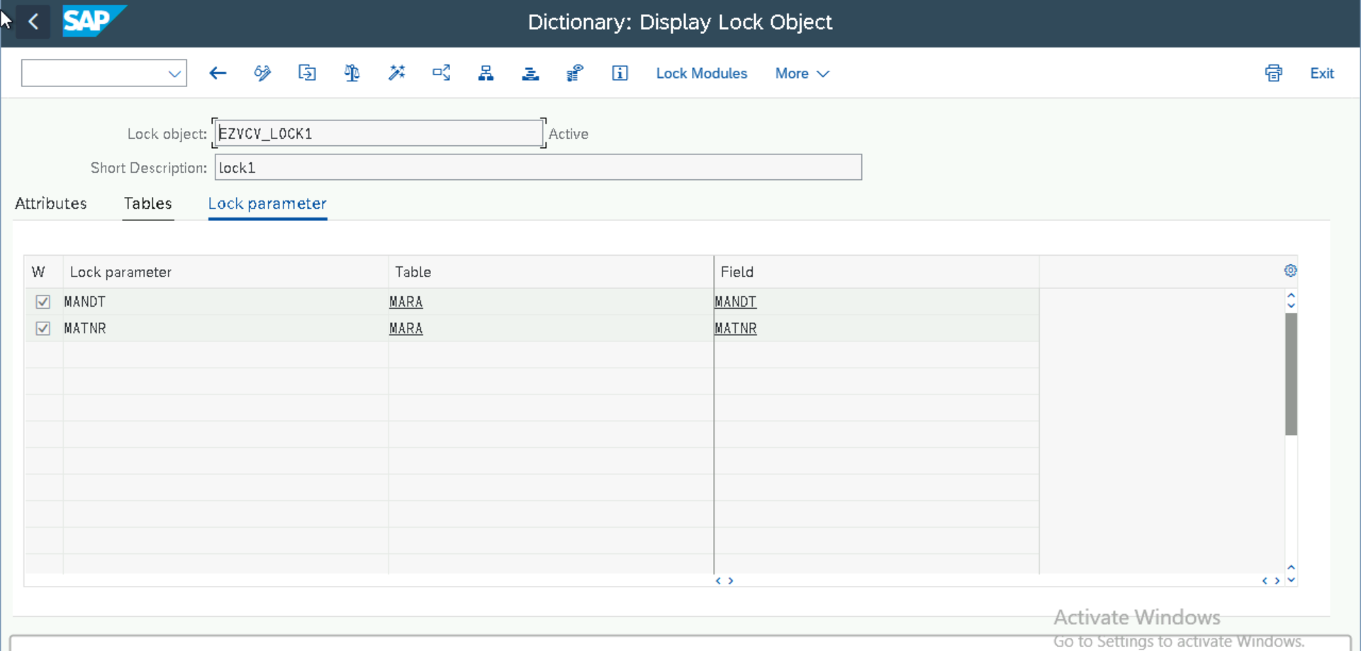

Program: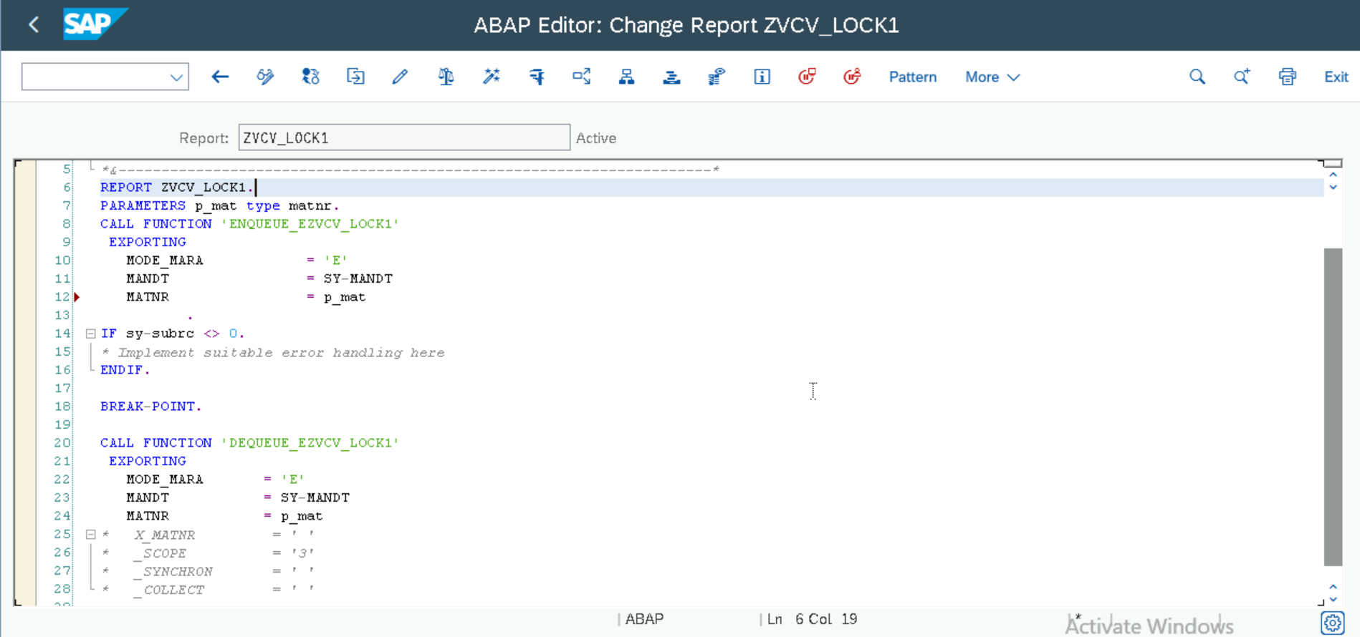

Material Master (MM01):

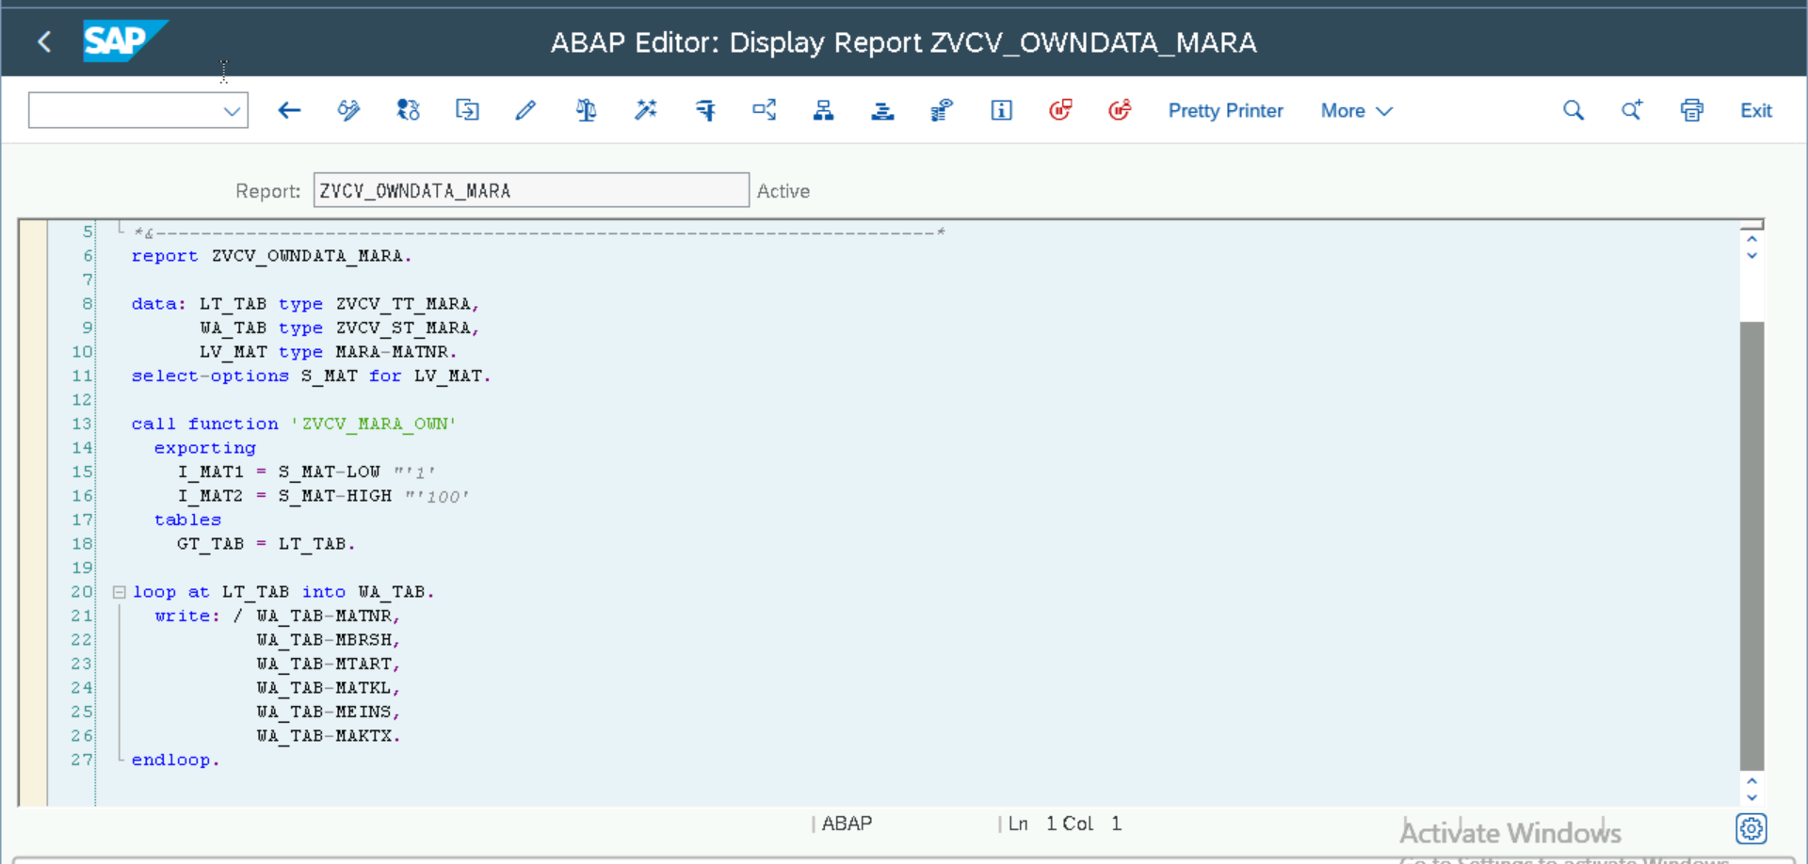

Output:

Sub-Routines and Function Module:

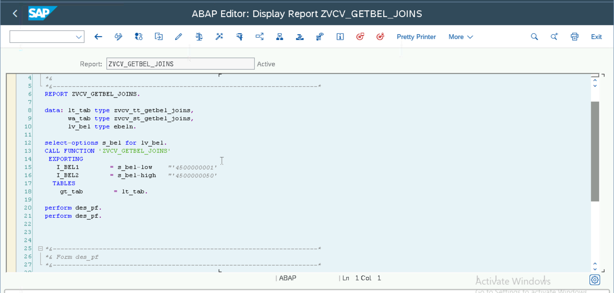

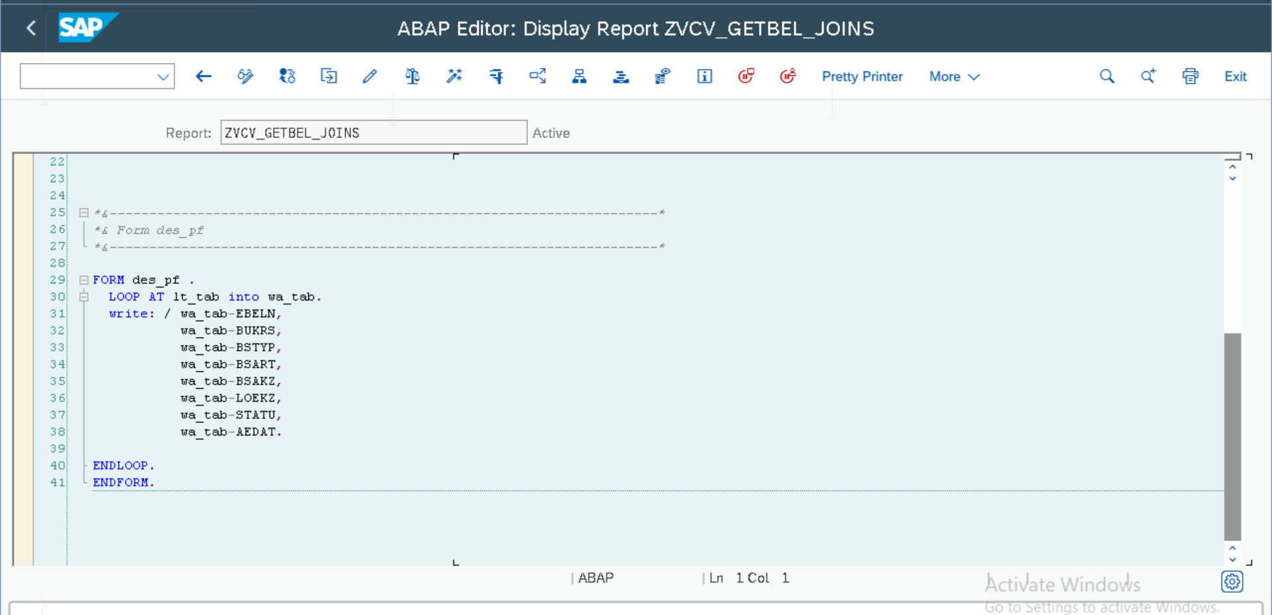

Output:

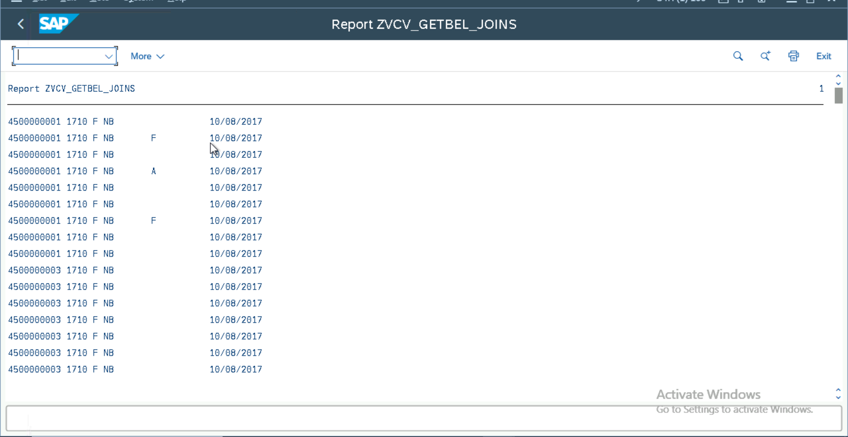

Function module:

Import: 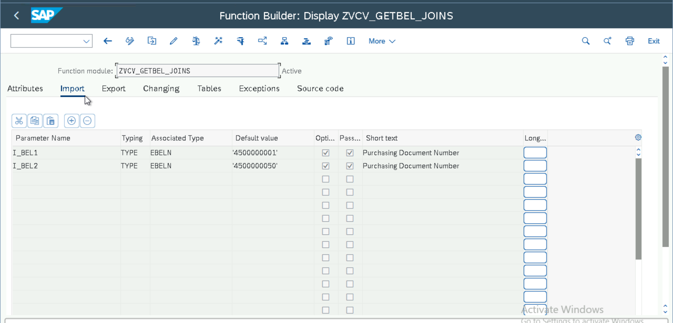

Source Code:

Selection Screen with Radio buttons, Check boxes, Blocks.

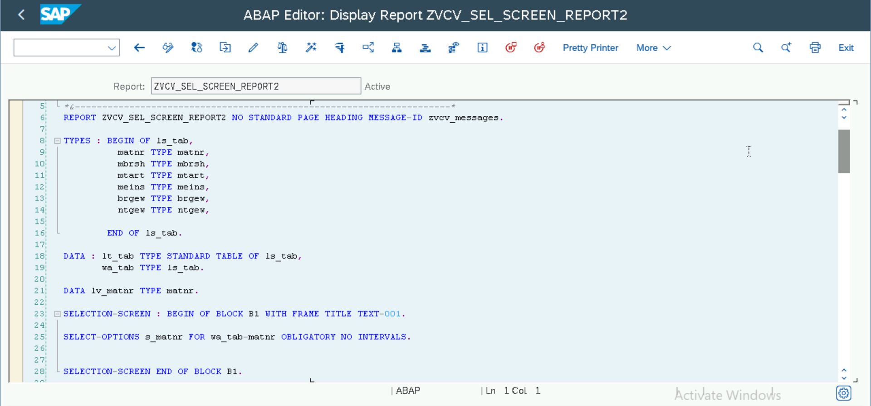

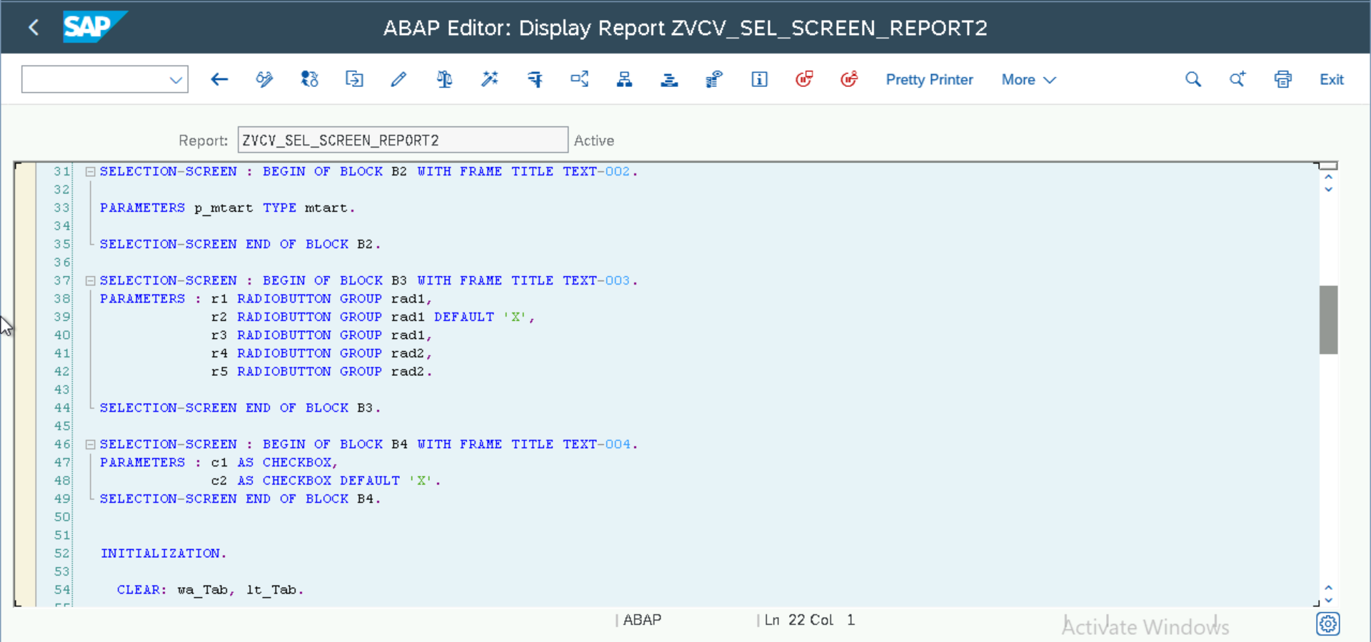

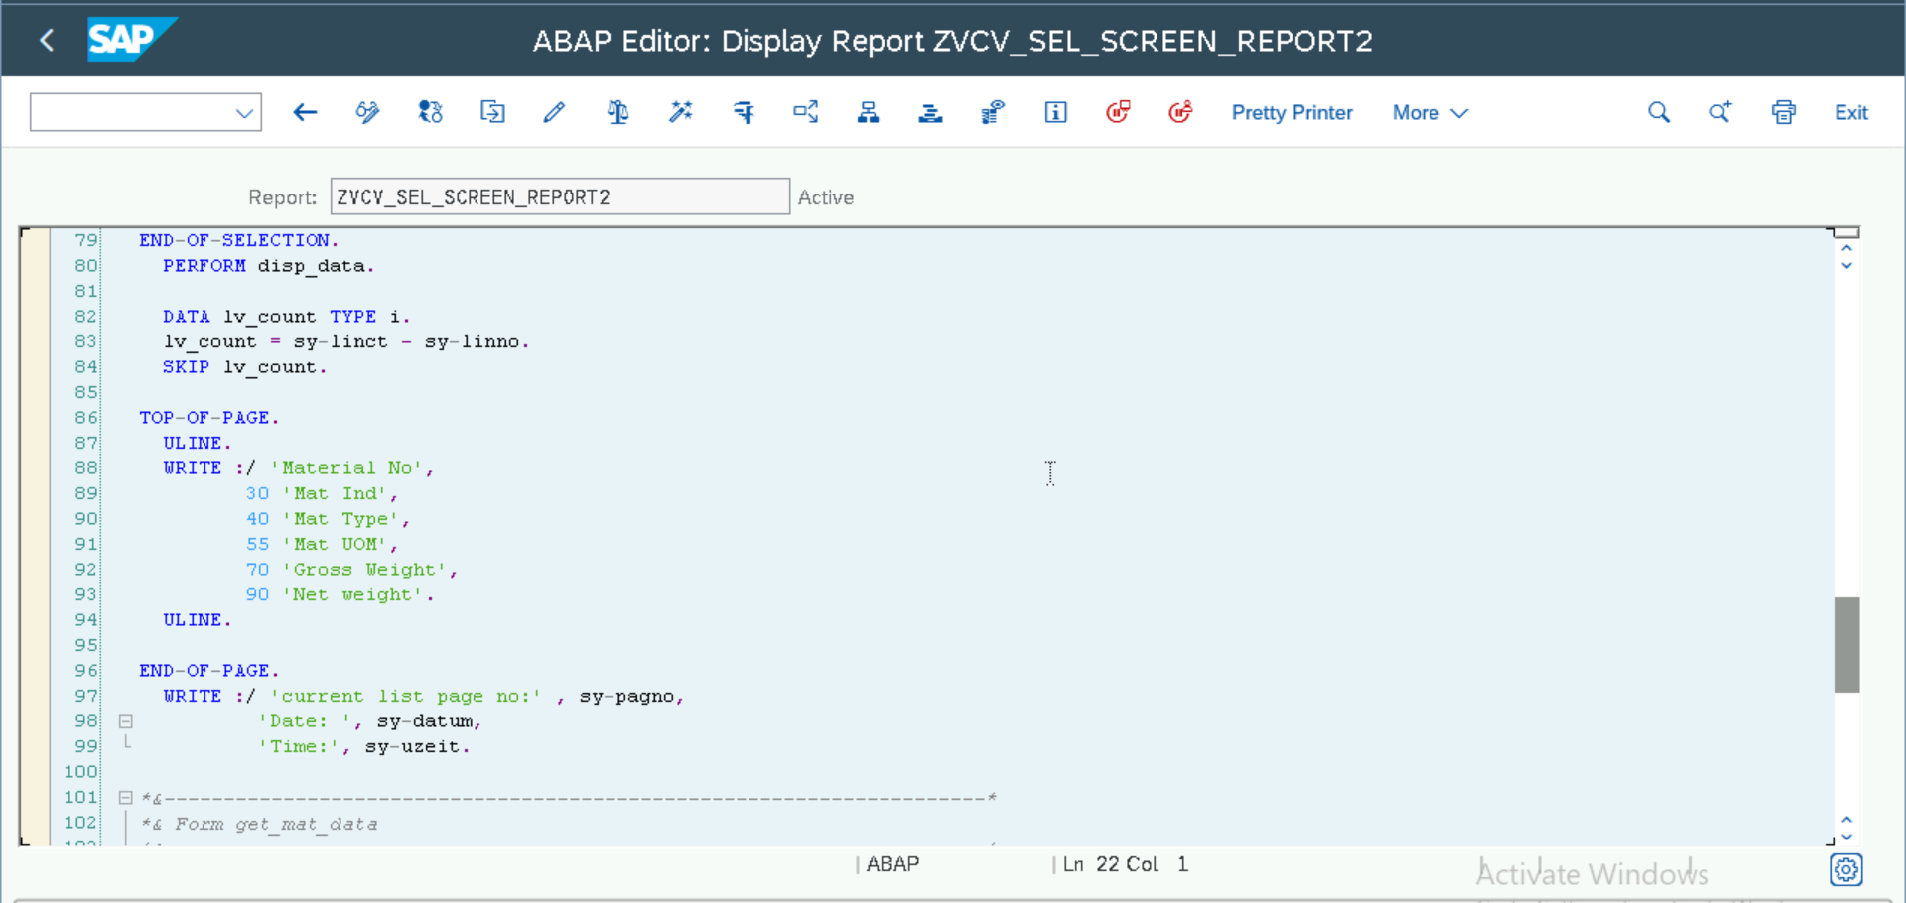

Selection-Screen:

Output:

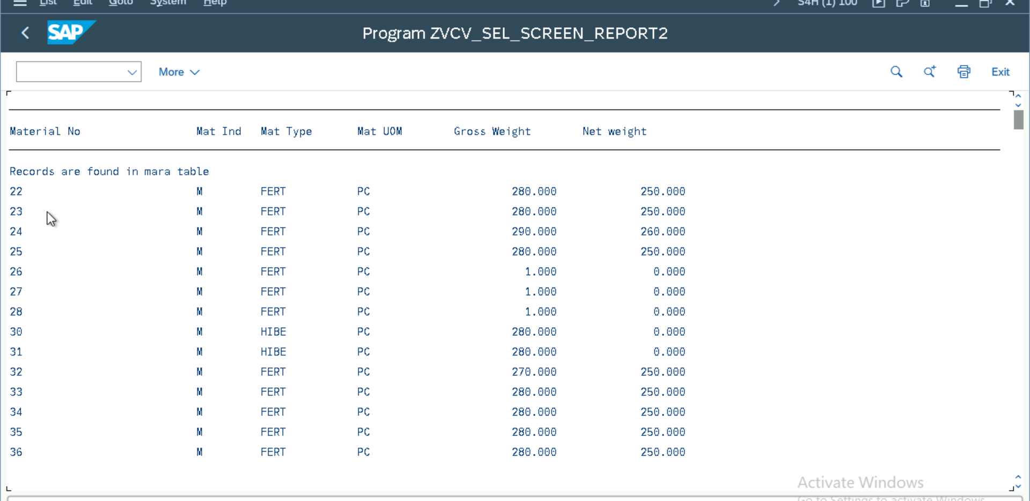

Classical Reports:

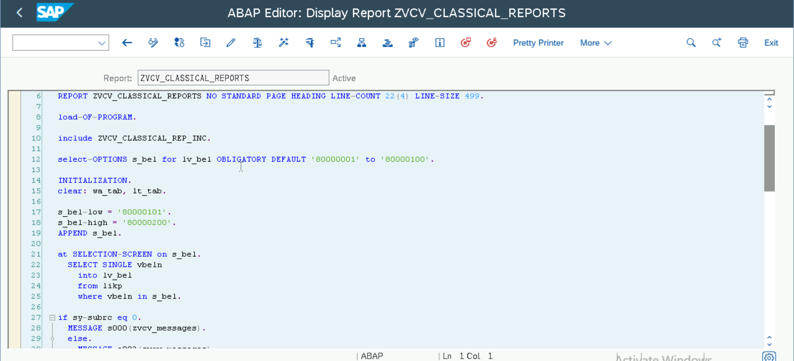

Output:

Interactive Reports:

1. At User Command:

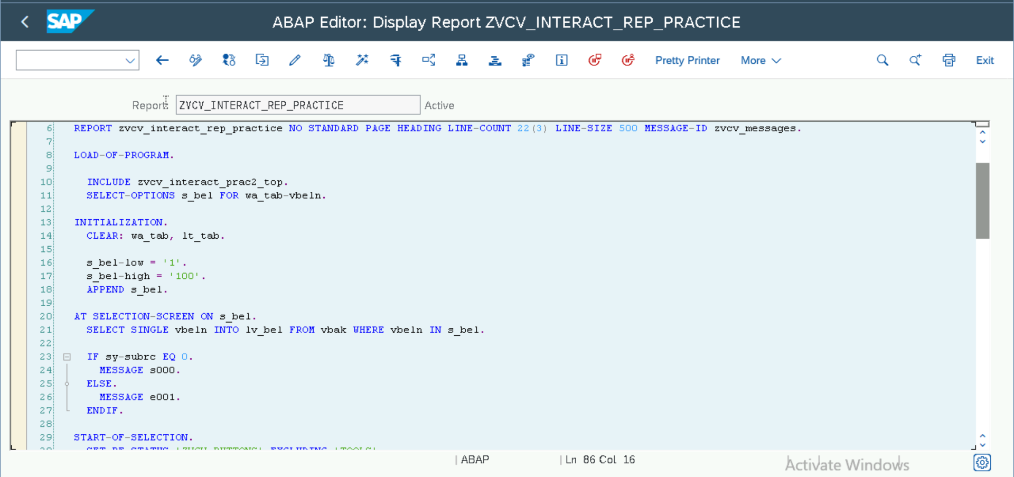

Output:

1. At Line-selection:

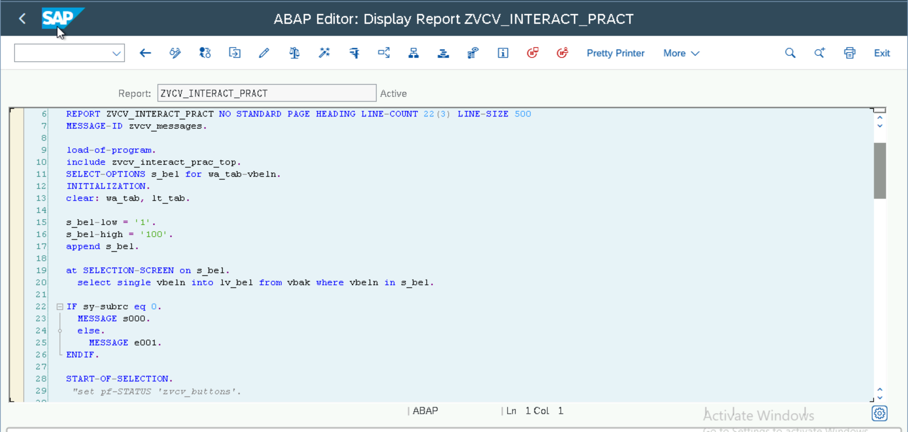

Output:

Basic List:

